**Model Evaluation**

Evaluation is a process during the development of the model to check whether the model is the best fit for the given problem and corresponding data.

**Classification Evaluation Metrics:**

These model evaluation techniques are used to find out the accuracy of models built in the classification type of machine learning models. We have three types of evaluation methods.

* Accuracy_score
* Confusion matrix
* Roc- Auc Curve

**Confusion Matrix**

It is a matrix representation of the results of any binary testing.

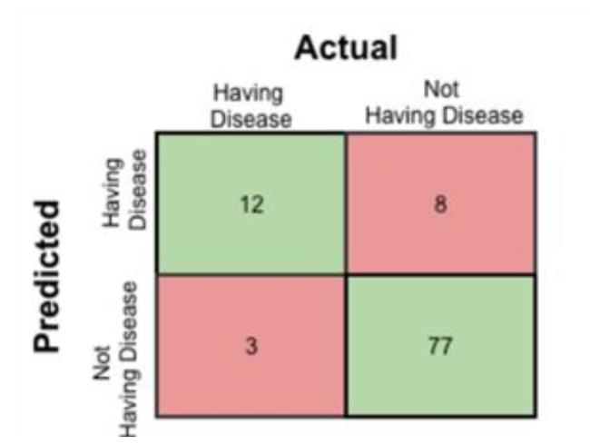

       Fig: Confusion Matrix of prediction of a disease

1. True Positive: 12 (You have predicted the positive case correctly!)
2. True Negative: 77 (You have predicted negative case correctly!)
3. False Positive: 8 (You have predicted these people as having disease, but in actual they do not have.)
4. False Negative: 3 (Wrong predictions )

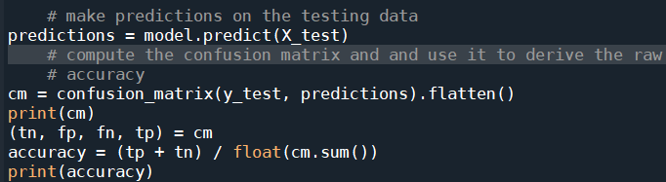

We can use the **predict** method on the model and pass **X_test** as a parameter to get the output as predictions.

The output of the confusion matrix and accuracy are as follows.

https://lh3.googleusercontent.com/BLwCe_HoqYBMcfoCisnJliRwvofKSkH9hnALcfJscDWmaSVpgRg12wroSOCJTK4sqBLo8e0HnqSNYG_e7eyWqhtFfx66QUP0CtpCEv7T-FHdW1V-UxS7RZMWBJR6EKMCEmLPiHiV